SUBJECT NAME AND CODE: WEB DEVELOPMENT
WEBE5020
FULL NAME: SAAHEERAH MAJIET
STUDENT NUMBER: ST10516777
GROUP: 1

TABLE OF CONTENTS:

Contents
BUSINESS PROPOSAL 1 2
1. Organisation Overview 2
Mission and Vision Statement: 3
Target Audience: 3
2. Website Goals and Objectives: 3
Goals: 3
KPIs: 3
3. Current Website Analysis: 3
Weaknesses: 3
Improvements: 3
4. Proposed Website Features and Functionality 3
Website Features 3
Website Functionality 3
5. Design and User Experience: 4
Colour Scheme: 4
Typography: 4
6. Technical Requirements 6
Hosting and Domain requirements: 6
7. Timeline and Milestones 6
8. Budget 7
9. References 8

BUSINESS PROPOSAL 1

1. Organisation Overview
NAME: Vida e Caffè
Vida e Caffè was established in South Africa, and the popular coffee shop brand has since evolved into a global franchise. This business focuses on offering customers throughout cities rapid assistance and excellent coffee. The company’s vibrant atmosphere and convenient takeout options have helped it gain popularity.

Mission and Vision Statement:
Vida e Caffè aims to be an outstanding coffee brand known for quality, reliability, and strong customer relationships.

Target Audience:
Workers, business professionals, and scholars who need urgent, high-quality coffee.

2. Website Goals and Objectives:
The goals of the website are to increase customer engagement and to promote the business.

Goals:
- Increase awareness of the business.
- Display items on the menu
- Provide the address of the business

KPIs:
- Exposure to websites
- Connection amongst consumers
- An increase in in-store visits

3. Current Website Analysis:
Strengths of the current website include menu information and clear advertising. In contrast, user interaction and responsiveness on mobile devices could be improved.

Weaknesses:
- Few interactive elements
- It could be better to navigate

Improvements:
- Incorporate options for online ordering
- Improve the customer experience on mobile devices

4. Proposed Website Features and Functionality

Website Features
The website will include the following key pages to ensure that users can easily access information:
- Homepage: Provides an overview of the brand, promotions, and featured products.
- About Page: Shares the history, mission, and background of the organisation.
- Menu Page: Displays available products, including coffee, beverages, and snacks.
- Store Locator: Helps users find nearby branches with location details.
- Contact Page: Provides contact information and enquiry options.

Website Functionality
The website will include functional elements to enhance user experience:
- A navigation menu that allows users to move easily between pages.
- A responsive design that adapts to different devices such as smartphones and tablets.
- An interactive store locator feature to improve accessibility.
- Fast-loading pages to ensure efficiency and user satisfaction.

5. Design and User Experience:
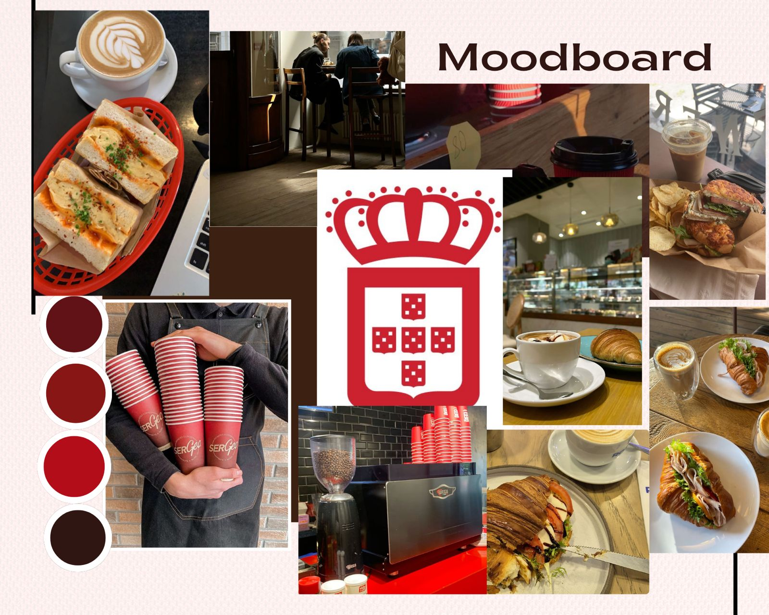

Colour Scheme:
The colours red, white, and black will make up the preferred colour scheme. These colours give the café a bright, vibrant, and modern look while also reflecting its brand identity. White and black will create contrast and enhance visual appeal, while red will be used to draw attention to important features such as call-to-action buttons.

Typography:
Simple and modern sans-serif fonts like Arial will be applied throughout the site. The headings will be larger and bolder to provide a clear structure, while the body text will be smaller and easier to read. This helps to keep the design consistent and makes it easier for consumers to read and understand the content throughout all pages.

Layout and Design:
A structured and simple design approach will be used for the layout. The information will be organised into separate sections using regular spacing. Images and posters are standard visual elements that will be implemented to improve the website's overall appearance and draw in visitors.

User Experience Considerations:
When creating the website, the customer quality will be the top priority. Customers will find it easier to navigate if the menu layout is straightforward and simple to understand. With the goal of ensuring that it appears smoothly on various devices, the structure will be flexible. The website will be easier to use, and because of the selected typography and colour design.

Low-Fidelity Wireframes:
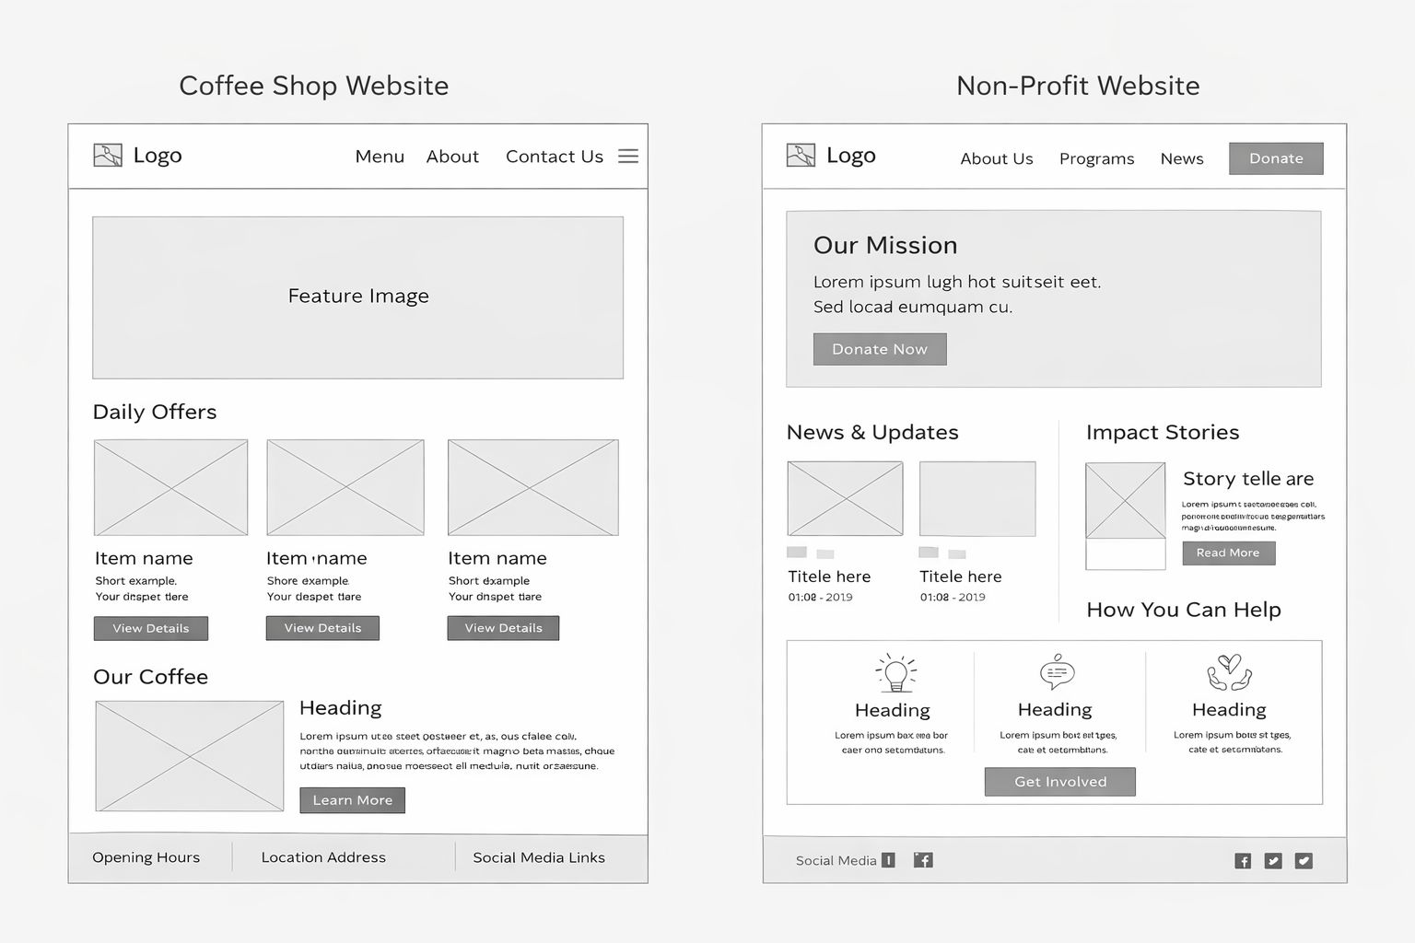

6. Technical Requirements

Hosting and Domain requirements:
* Domain: swanked.co.za - current website's domain
* Hosting: Managed shared cloud hosting - uses outsourced infrastructure to manage server maintenance, security patching, and scaling.
* Security: SSL/ TLS certificates (HTTPS) - It protects sensitive data, like payment card details and login credentials, by encrypting data whilst it is being transferred between the user's browser and your server.
* Availability: 99.9% uptime SLA - provides constant brand accessibility, vital for production drops and sales.

7. Timeline and Milestones
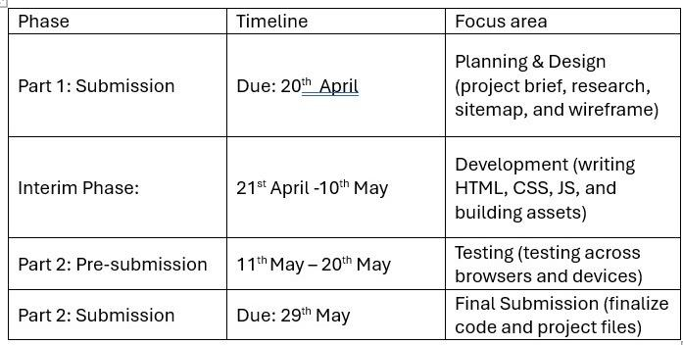

8. Budget
The estimated budget for the website is based on basic development and hosting needs.
- Domain name: R100 – R200 per year
- Web hosting: R300 – R600 per year
- Development tools (VS Code, GitHub): Free
- Images and resources: Free (using royalty-free platforms)
Total estimated cost: R400 – R800 per year
This budget is affordable and suitable for a small-scale website project.

9. References
Duckett, J., 2011. HTML and CSS: Design and Build Websites. Indianapolis: Wiley.
Mozilla Developer Network, 2025. HTML, CSS and JavaScript Guide. Available at: https://developer.mozilla.org (Accessed: 20 April 2026).
W3Schools, 2025. Web Development Tutorials. Available at: https://www.w3schools.com (Accessed: 20 April 2026).
Unsplash, 2025. Free stock images. Available at: https://unsplash.com (Accessed: 20 April 2026).
Pexels, 2025. Free stock photos. Available at: https://www.pexels.com (Accessed: 20 April 2026).
Pixabay, 2025. Free images and royalty-free stock. Available at: https://pixabay.com (Accessed: 20 April 2026).
Vida e Caffè, 2026. Official Website. Available at: https://www.vidaecaffe.com (Accessed: 20 April 2026).
ChatGPT, 2026. ChatGPT (April version). Available at: https://chat.openai.com (Accessed: 20 April 2026).
QuillBot, 2026. QuillBot Paraphrasing Tool. Available at: https://quillbot.com (Accessed: 20 April 2026).

